1080 HD mini CAMERA
WEBCAM/CCTV/BODYCAM
CAM-CA90

The CAM-CA90 is a mini 2M Camera with three in one functionality which can be used as a CCTV Security camera , a body camera or a regular web camera. The CAM-CA90 has a built in microphone a SD Memory Slot for recording and a lithium rechargeable battery.

The battery can be charged via the USB port connected either to your computer laptop or a regular charger in the wall.

The CA90 camera can function as a body camera, allowing the user to either clip it on clothing or on head gear and can record using an SD memory card

The CA90 can function as a webcam and is supplied with a holder that can be placed on the monitor or stand by the computer and can be used for video conferencing.

The CA90 can function as a CCTV and is supplied with a holder that can be placed anywhere in a room and has a SD memory card port for recording and storing video.

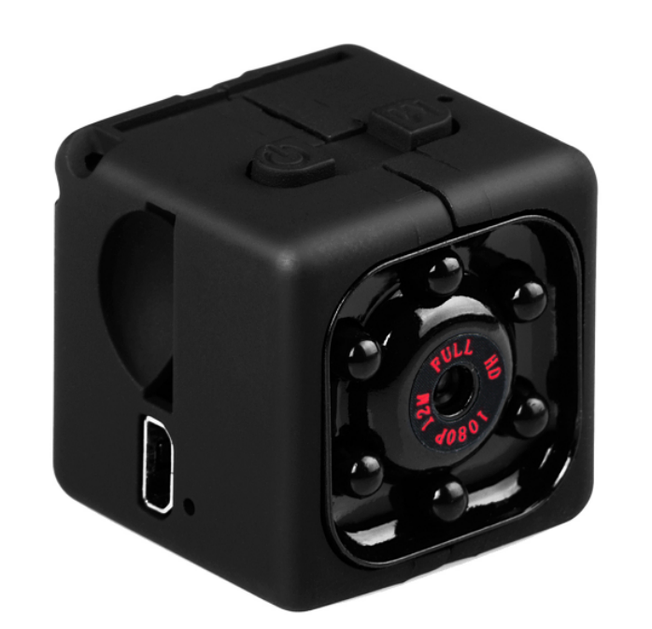

SPECIFICATIONS:
Sensor.2Mega CMOS sensor GC1024
Aperture: F 2.0
Focal length: f= 2.9mm
Memory. TF Card, up to 32GB (Not included)
Microphone: Built-in
Battery. 3.7V 200mAh
USB: High speed USB2.0 Micro
Image Resolution: 12M(4032x3024)
File format: JPEG
Video resolution: 1080P/960P/30FPS, 920P/30FPS
Video (compression) format: AVI(M-JPEG)
Continous Video Recording Time: Video Recording about 50 minutes
Operating Temperature: -10~50 °C
Storage Temperature: -10~70 °C
Humidity environment: 5%-90%(No condensation)
Plastics accessories: Have
Size(mm): 25mm* 24mm* 24mm
Weight: 20g

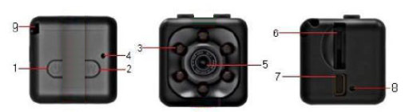
1 ON/OFF Key
2 Mode key
3 Infrared lamp
4 LED indicator
5 UIltra wide Angle 6 TF card port
7 MINI USB port
8 Rest port
9 Sling

Product features
●High quality high-definition imagesFULL HD DVDC
●Import hd camera
●Compact design, portable handheld DV DC
●Under low ilumination, hd video recording can be
Performed
●Video format for:720X480P
●Video format for:1280X720P
●Video format for:1920X1080P
●Mode for taking pictures: 12M(4032X3024)
●Motion detecting video: 1080P
●USB 2.0 interface of high speed transmission
● Biggest can support 32 gb T - flashCARDS
”Built-in lithium battery sustainable camera up to 100 minutes

Operation instruction
charging:
The machine built-in rechargeable lithium battery, first time using
this machine, please charge, can be charged by the following way:
1) Connect computer charging, the use of USB connect with computer
2) Can charge while recording, video can also charge (an external USB 5 v charger or mobile treasure).
3) After charging flashing red light, full of red lights long said charge, (red lights, please charge again more than 30 minutes to ensure that battery is 100%)
Note: 1: when the battery is insufficient, T recorded in the card is full, DV red and blue light will flash for 5 seconds after directly into protection state of shutdown, (save the file and automatically shut down) recording file has been saved, at this time, please charge on this machine
2: Products without a card, red and blue lights flash for 5 seconds
automatically power off at the same time
3: No work after boot mode, 1 minute automatic shutdown
One cable with three functions:
USB with TV cable 1: Can be inserted into the computer for the machine is charging and data transmission
2: Can plug in TV OUT screen display .
3: Can insert DV 5 v charger while external record.
video not flash:
Click ON OFF button to boot, boot blue light normally ON, click ON the switch machine, under the blue lights flash 3 out of 720 p video, video process lamp don't suggest, a segmented automatically save 5 minutes continuous video, cycle cover,click the switch button again to stop video, back to the blue light normally ON standby mode.
Picture 12 million:
On standby mode, press mode button for 2 times long red light for picture mode, then click on buttons flash a red light, photo 1, 12 million pixels (4032 x3024) automatically saved
Infrared lamp open closed:
Open: boot any standby mode, press and hold the ON/OFF 2 seconds under the red light flash 2 infrared night vision lamp open, can see video
Close: infrared night-vision light, no standby mode, press and hold the ON/OFF 2 seconds, the red light flash 2 to shut down the infrared night vision under the lamp.
Motion detecting mode
motion detecting: in blue light standby mode, press mode key for 3 seconds, red light flashing on the long 3 under blue lights open motion detecting video mode, both have detected objects move after, red and blue lights flash for 720 p mobile video at the same
time, a period of five minutes, automatic packaging to save, don't cover, cycle cover ,there is no moving object standby all the time without electricity or T card record. (click on any button 1 exit motion detecting mode) insert the T card, external insert USB TV line, the external USB 5 v power supply, or charging treasure, machines directly into 720 p video mode, no manual stop has been recorded at the card with or without power, can also be manually stop video switch any mode.
Invalid reset:
machine crashes, buttons, can't normal use, can use a sharp object to reset reset hole insert to the machine, can use normally after reset.
Power off:
in the stop (video, pictures, motion detecting) function mode, the need to shut down, long press ON/OFF button for 6 seconds or so, see the red and blue lights to turn it OFF. Or in standby mode without using any power function can, standby for 1 minute automatic shutdown.
Time to change the setting on its own:
The machine will automatically create a TXT document in the TF directory, Kagan (pictured), shutdown data line connected to the computer, on a removable disk to open the TIMEREST.txt text document, edit their required time, such as format (the
date when) save text files after 20160804174726 Y boot record video can be save the file, it will display the video editing time. Does not require time watermark is the same mode of operation, mainly the difference between the tail of the letter Y and N. Refer to the following format:
1:20150608192526 Y (time watermark display)
2:20150608192526 N (no time watermark display)
Notice:
a.Please be sure to confirm the product has been inserted in the T – flash (Micro SD card. In the absence of card products double flashing red and blue lights can't normal use
b.Please in sufficient lighting conditions, is taken by the camera to like, and subject to keep a distance of more than 50 cm, this will be correct, the color is natural, the scenery is clear, the stability of the images.
Connect the computer:
On standby and off, can be connected directly to the computer, connect the computer after can be used as a U disk, files are free to copy, and paste, delete, format the U disk.
Insert the machine into the computer USB port, the computer will pop up a few seconds after removable disk logo, the blue indicator to identify USB device can carry out data transmission, the red indicator for charging, the red light is full of.
Reminder:
a. After the machine to connect the computer, if the computer can't identify, or still did not pop up in 30 seconds removable disk logo, please reset to plug again.
b. Suggest using the T card reader directly read the video files to play, and play directly by USB connection in the video file, in this video recorder built-in memory may be because the data volume is too big, transport couldn't keep up with, to play not smooth.

Relevant parameter
Video format：AVI
Video coding：M-JPEG
video resolution ratio：720*480P 1280X720P 1920X1080P
Video frame rate：30 fps
Player software：operating system or bring the mainstream video player software
Picture format：JPG
Image proportion：16:9.
Support system：Windows me/2000/xp/2003/vista;Mac os;Linux;
Battery capacity：200mAh
Working time：About 100 minutes
Charging voltage：DC-5V .
interface type：Mini 8Pin USB
Storage support：TF card
battery type：High capacity polymer lithium electricity

Note:
After each use of the battery recharging, it takes about 2-3 hours or so to completely filled with filling, each full red and blue lights all 30 minutes again, as far as possible after the battery full use.
Because of this product is a real HD high DV, product consumption current is bigger than general please, use zinc alloy shell material, and when using the product may have some hot state belongs to the normal phenomenon, don't have to worry about bad products appear, is a long time after aging test to ensure that product quality
problems before shipment.
Matters needing attention:
Use occasions: please strictly abide by the relevant national laws and the product may not be used for any illegal purpose, otherwise the consequence is proud.
Working temperature: please use under natural temperature, do not work in the human body can not adapt to the temperature
Working humidity: please use under suitable for human living environment humidity, please do not put product in damp working environment, the product does not have waterproof function, please keep this product pour water or exposed to rain water Shooting illumination: please have adequate light source under the environment of use, do not use such as super light source, camera directly into the sun to avoid optical device is damaged.
Cleaning: do not use in excessive dust density environment, in order to avoid the lens and other components from dust, impact camera effect Waste treatment: please pay attention to environmental protection, do not throw this product. Forbid throwing this product in the fire, so as to avoid explosion.

